In this Lab we will work on App Engine firewall configuration. We will see how we can block access from whole internet to App Engine service and how we can allow access to specific IP address.

Go to App Engine on GCP console, Go to services and try opening any of the service we created previously, like Inventory2 (it should open the webpage)

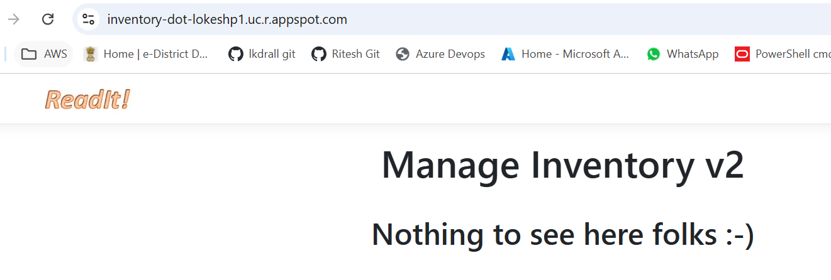

As of now, this service is accessible from whole Internet

Now go to Firewall rules page, here it will show a default rule already exists which allows all traffic

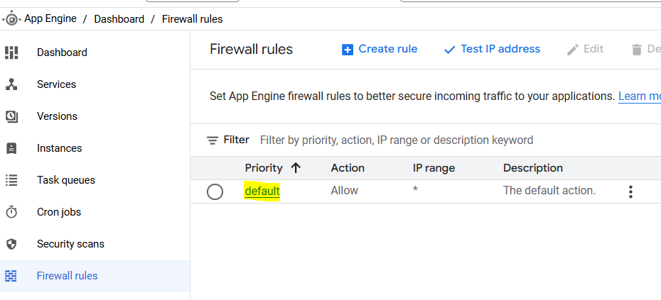

Open the default rule, click Edit and make it to Deny

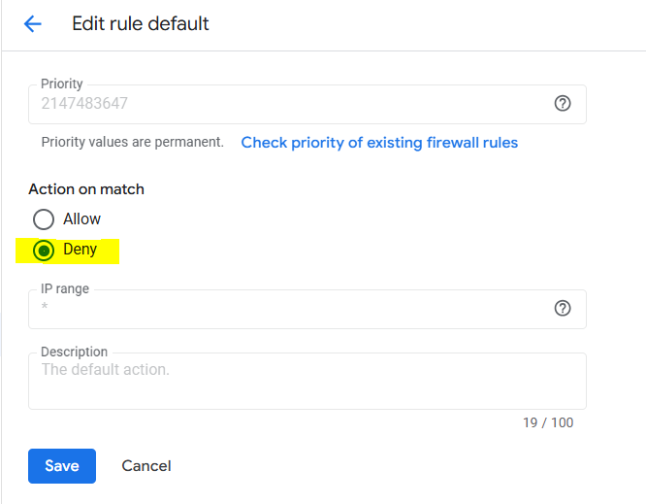

Now again try access the inventory service, it will give an error

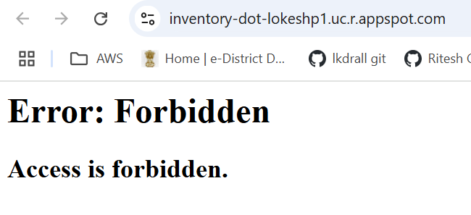

Now go to Google and search What is my IP, and copy your public IP address (it may be IPv4 or IPv6)

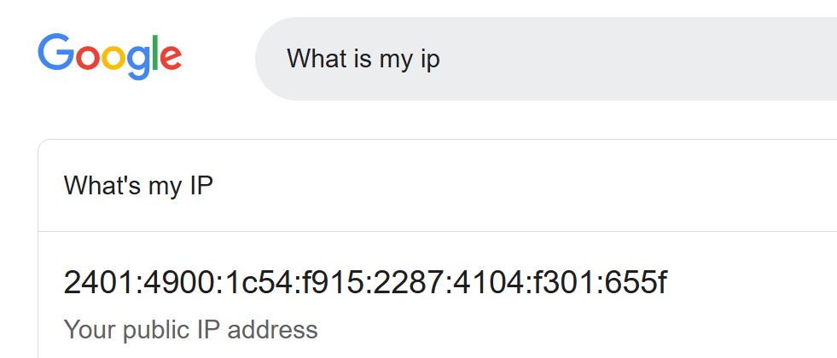

Go to Firewall rules, click Test Ip address and paste your public IP, click Test

It should show as denied

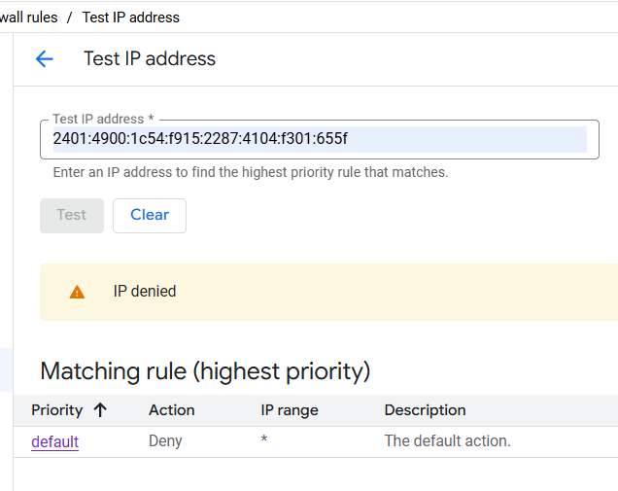

Now create a new rule for allowing your public IP address (make sure to give priority number shorter then the default rule as shorter the number higher the priority)

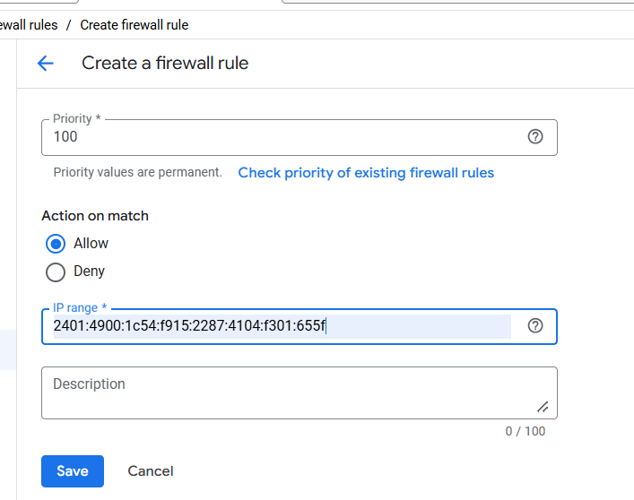

Then again test your IP address and this time it should show as allow. Note that, Default rule deny all traffic, but as the priority number of your IP address rule is shorter so means it has higher priority, so it will show as allow

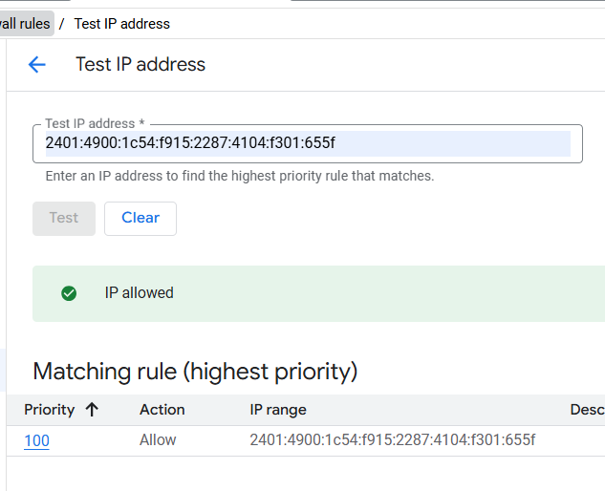

Now again try to access inventory service and this will again work for you.

But if you will try accessing this service from some other pc or once your IP address is changed then it will not work as we have allowed it for that specific IP address

This is why we always prefer to use range or fixed IP addresses for the firewall rules.